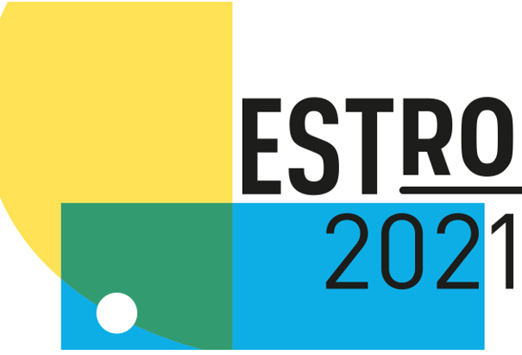

MEDIA FREE REGISTRATION APPLICATION

EMAIL completed form (together with media accreditation documents)
to the ESTRO Communication Department:

Email: lctumbarell@estro.org
FREE REGISTRATION is available for bona fide media representatives. ALL MEDIA are required to enclose a copy of a recognised press card or a commissioning letter from the editor of a recognised publication when returning this form AND to present them at the conference together with valid passport or ID-card. To register for the online congress, 2 bylined articles are requested in addition to the above.

I will attend ESTRO 2021 taking place between 27-31 August 2021:

On site in Madrid
Online congress only
I agree to abide by the ESTRO 2021 media policy.

First name:.….. Family name:

Representing:

Job Title:

Address:.……………………………………………………………………………………………Postal code:......................................................................................................

City/Country..…………………………………………………………………………….……..Telephone Intl:..................................................................................................

E-mail: ……….……………………. ………………………………………………………………URL/Internet address: ....................................................................................

I enclose a copy of my Press card

I enclose a copy of a commissioning letter from the editor of a recognised publication

I enclose a copy of 2 bylined articles (only requested to register for the online congress)

TYPE OF PUBLICATION

Newspaper (National/Regional)* Magazine (N/R)*

News Agency (N/R)* Scientific Journal (N/R)* Radio (N/R)*

TV (N/R)* Website CME publications
Other (please specify): ………………………………………………………………………………………………………………………………………………….……………..……………...

*Please indicate whether you are National or Regional media in your own country
Area: News/ Science/ Research & Development/ Health/ Other (please specify): …………….……………………………………………………………………..............

Please note: CME publications may only register two representatives as media. Advertising, marketing and public relations staff from journals or companies are NOT eligible for free media registration. Please consult the conference media policy at www.estro.org

