START-UP CORNER
EXHIBITION SPACE RENTAL

To be returned to Hande Van Gestel by email hyilmaz@estro.org

Bookings for spaces in the start-up corner are open to start-up companies only (start-up: company which has been in business less than 5 years and has fewer than 10 employees)

Please complete in capital letters. ESTRO cannot be responsible for mistakes resulting for illegible handwriting.

COMPANY DETAILS

Company name
Invoicing address
Contact person
VAT number (if applies)
Purchase order number - PO (if applies)
Tel
E-mail …………………………....
Company website ………………………....

COMPANY DETAILS TO BE PUBLISHED IN THE CONFERENCE PROGRAMME BOOK (if different from above, please complete)

Company name
Company Address
Contact person
Tel…………………………....
E-mail …………………………....
This application is legally binding for the exhibitor pending its acceptance in writing by the organiser.

By signing this application form, you declare that you have read and accepted the ESTRO Rules and Regulations.

Name: Title:

Signature: Date:

BOOKING OF NETWORKING SPACE

Price per space: € 1,500
The start-up package offered by ESTRO includes:
- 1 table
- 2 chairs
- Electricity
- 1 roll-up (0,85m width x 2,05m height)*
*The artwork of the roll-up should be provided to hyilmaz@estro.org by 19 July.

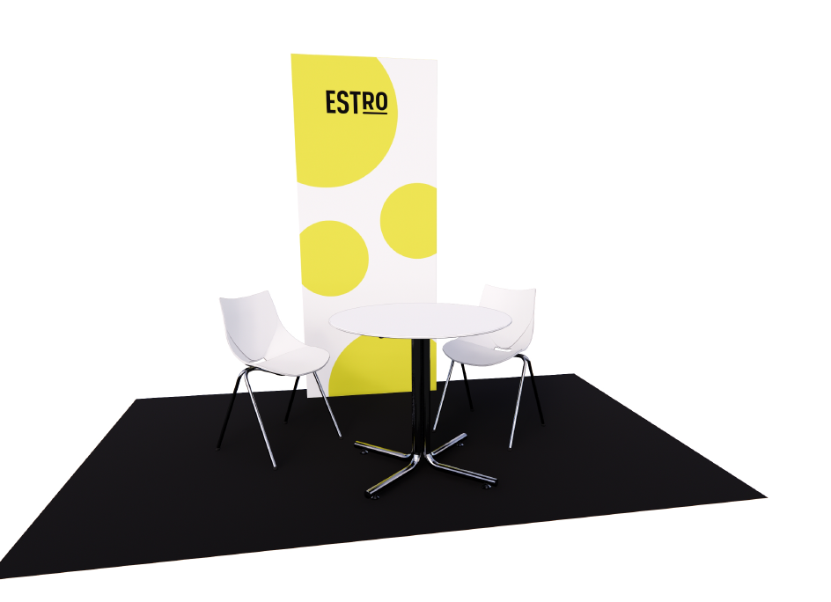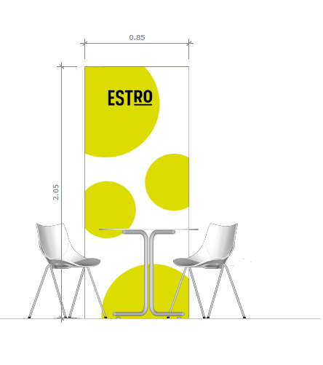

NOT included in the start-up package:
- Additional exhibitor orders
- Daily cleaning

We prefer the following booth locations: 1st .................. 2nd .................. 3rd..................

